Household Medication for Dogs
Product | Common Usage | Canine Dosage
Benadryl | Treats allergies, itching etc. | ½ mg per 1lb. Every 8 hours. Maximum dosage 2 mg per lb  0.4ml childrens liquid Benadryl per lb . Most adult tablets are 25 mg each. So 100lb dog would need 2 | 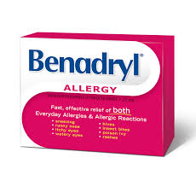
Buffered Aspirin | Pain relief and anti-inflammatory | 5mg per lb every 12 hours | 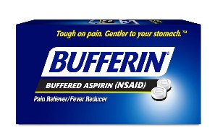
Digel Liquid | Antacid and anti-gas | Up to 4 tbs Every 8 hours | 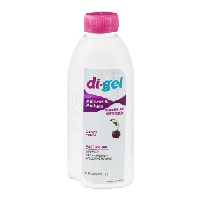
Gravol | Reduces motion (car) sickness | 1/2 of a 25 mg tablet for smaller dogs, up to 25 mg for larger dogs, every 12-24 hours as needed for nausea. | 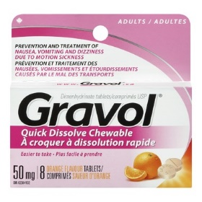
Hydrogen Peroxide 3% | Used to induce vomiting after accidental engestion of poisons | 10 ml by mouth every 15 minutes  CALL VET | 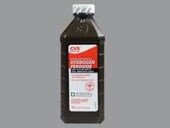
Imodium AD | Relieves diarrhea | 1 ml per lb Every 8 hours | 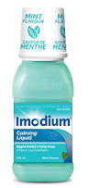
Kaopectate | Relieves Diarrhea | 1 ml per lb Every 2 hours | 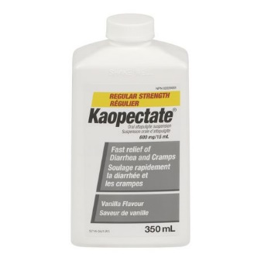
Mineral Oil | Eliminates constipation | Up to 4 tbs daily | 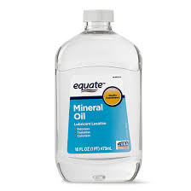
Pepto Bismal | Eiarrhea, anti-vomiting and gas | 1 tsp per 5lbs Every 6 hours | 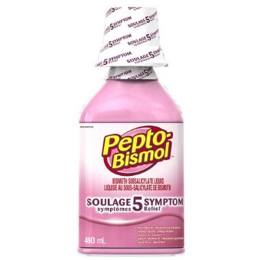
Tylenol | DO NOT USE | DO NOT USE

